TPK4128 Exercise 2 – Concurrency
Assignment A
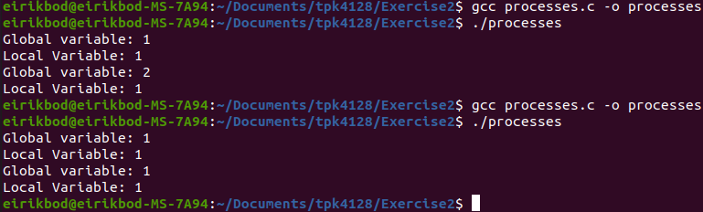
When run with vfork (first call above), the global variable is accessible from the child process, and thus is incremented in both functions. Vfork creates a child process and blocks the parent until the child process is exited, the child gets access to the memory space of the parent function, and can thus update the global variable, which is carried over to the parent process.
The second call uses fork, and this makes a child process and a parent process, which runs in different memory spaces, but the memory spaces has the same content at the time of fork. This means that the 2 processes cannot increment/update the same variable, ass seen from the printed values.

See git for code files.

